A

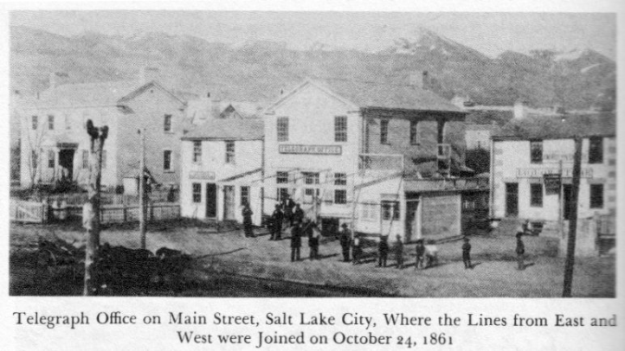

B

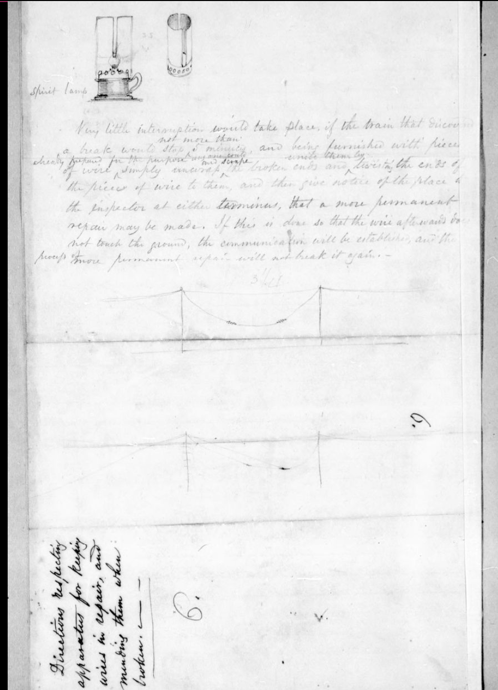

C

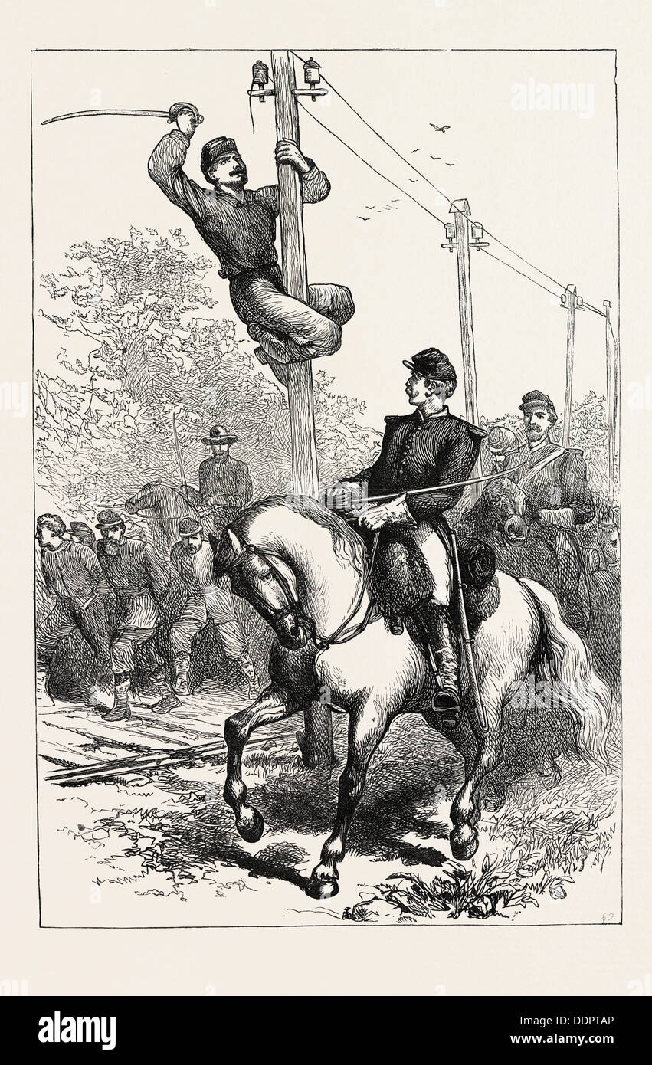

D

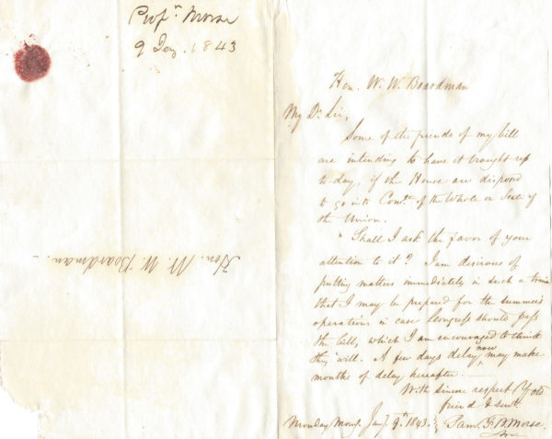

*“Some of the friends of my bill are intending to have it brought up today, if the House are disposed to go into Committee of the Whole on State of the Union. Shall I ask the favor of your attention to it? I am desirous of putting matters immediately in such a train that I may be prepared for the summer’s operations in case Congress should pass the bill, which I am encouraged to think they will. A few days delay now may make months of delay hereafter.*

* *Samuel Morse”*

E

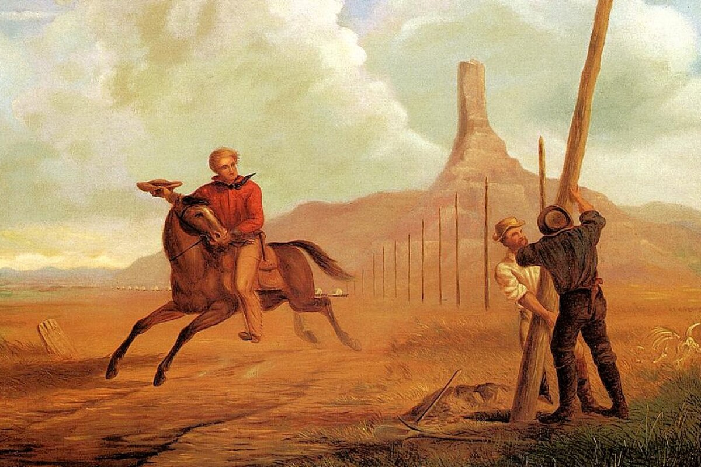

F

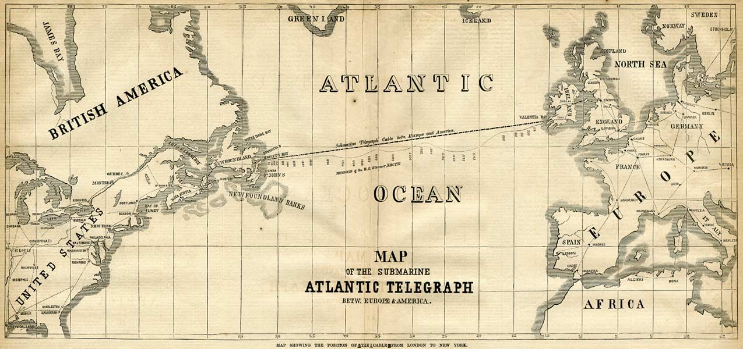

G

**Cost of Sending a Telegraph from Denver in 1863**

|  |  |  |  |
| --- | --- | --- | --- |
| **Message Destination** | **Cost in 1863 dollars** | **Cost in today’s dollars** | **How much can that buy in 2021?** |
| St. Louis | $7.00 per word | $152.39 per word | LEGO Architecture San Francisco 21043  3 Lego architecture sets per word |
| New York | $9.00 per word | $195.54 per word | Lego Star Wars Boba Fett's Starship 75312 Building Toy; Awesome Gift Idea for Kids (593 Pieces), Size: Standard  4 Lego Star Wars sets per word |
| Boston | $9.00 per word | $195.54 per word | Lego Star Wars Boba Fett's Starship 75312 Building Toy; Awesome Gift Idea for Kids (593 Pieces), Size: Standard  4 Lego Star Wars sets per word |

H

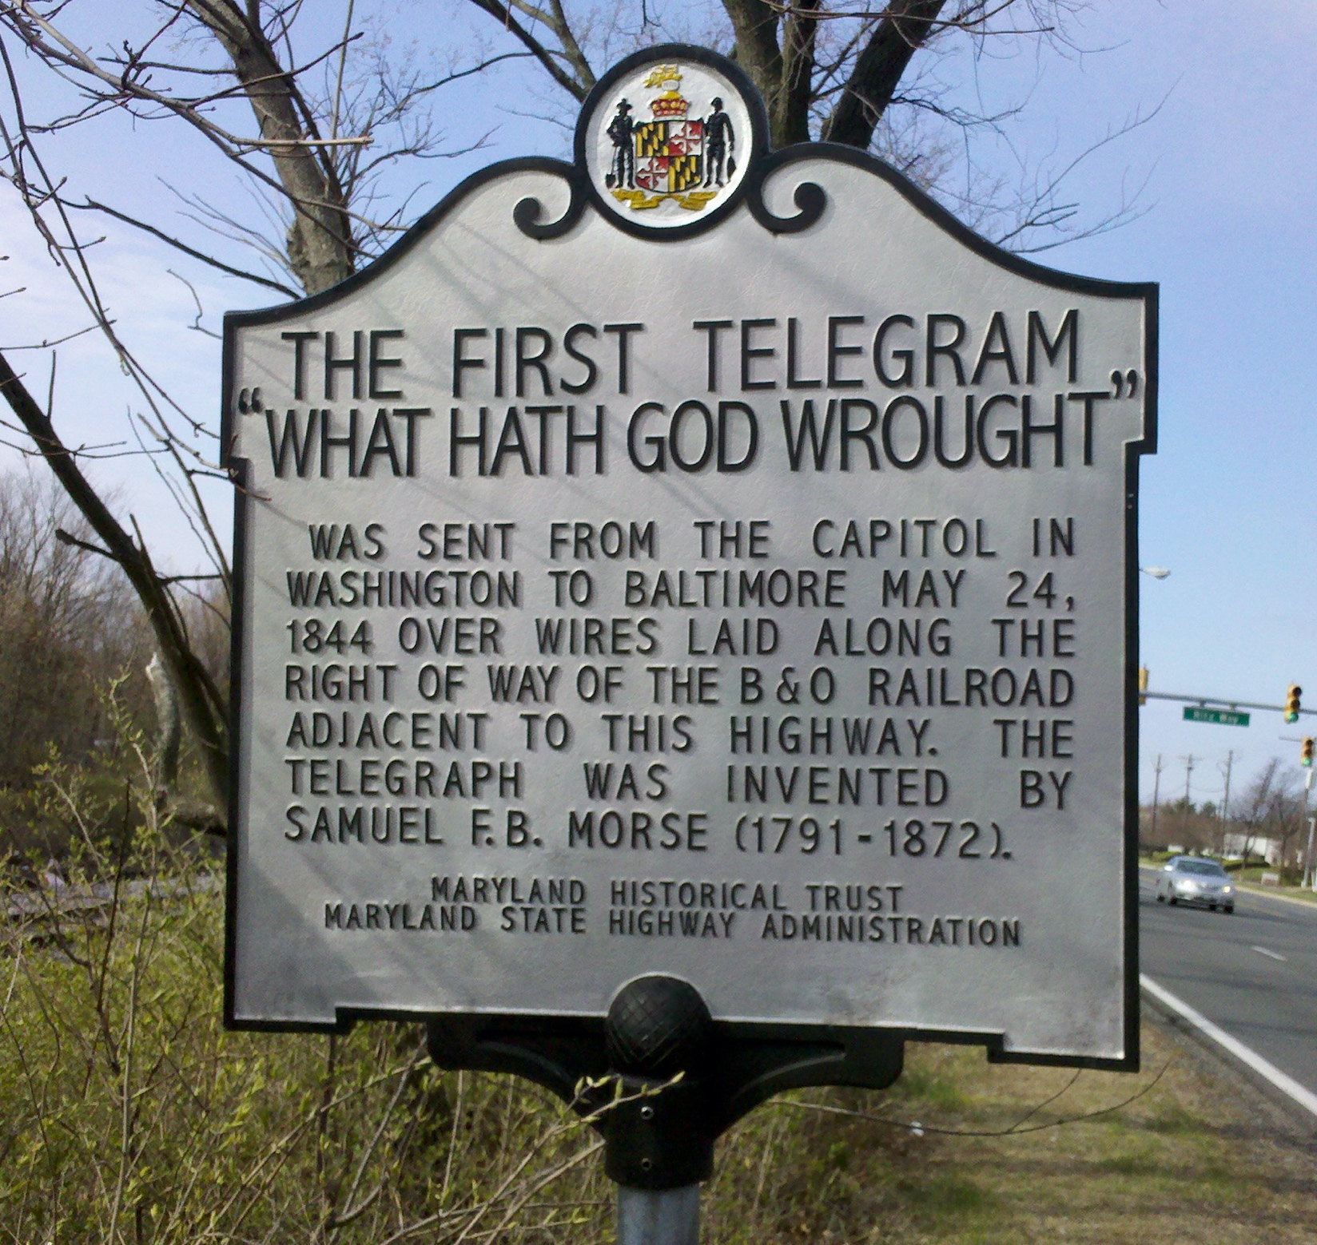

I

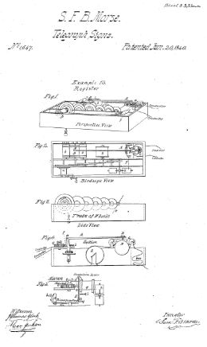

J

